**Index**

1. Start-up Information
2. Home page
3. Editor
4. Products & Services & SEO
5. Template image replacement
6. I-Frame Facebook and Google Maps
7. **Start-up Information.**

[**https://youtu.be/9799xK0yOsE**](https://youtu.be/9799xK0yOsE)

Registration Link:

1. <https://www.kwikwap.co.za/warehouse.php?conCode=finpro>

During this process you will be able to choose a 100% customisable template.

Client Login Link:

1. <https://clientzone.kwikwap.com/login.php>

After you did your registration the login details username, and password will be emailed to you.

You will now be able to login to your Web builder portal link 2. Above.

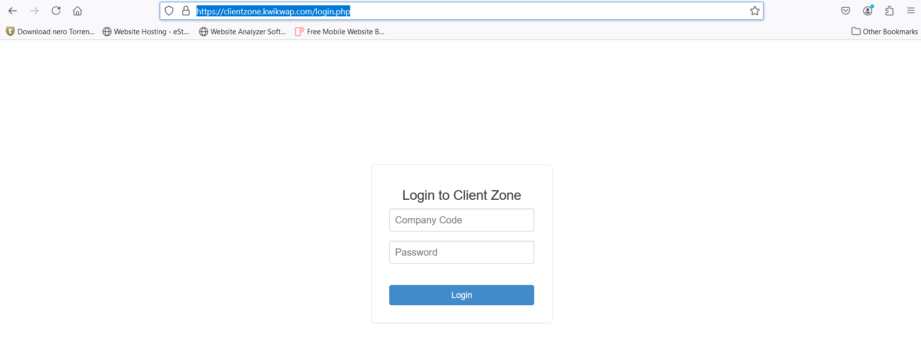

Use login credentials emailed to you.

This is a Demo website and will only to be activated once completed. Once activated prorated billing will start.

Before we go live you need to register your Domain. This is an address or name a client type to enter your website. <https://www.yourname.com>.

https:// - Shows this website is secured.

www. – World wide web.

Yourname – Your chosen name for your website.

Domain extension - .com - .net - .org – co.za and more extensions.

1. Pricing Once Off:
2. We Design R3500-00. Basic design.
3. You Design FREE.
4. We assist R85-00 per Half Hour.
5. Pointing R150-00.
6. Domain name Depend on your extension .com .net co.za and more. Yearly renewable.
7. Monthly Fee:
8. Starter R100-00.
9. SME R200-00.
10. Hosting R40-00.

A.1 We Design Include:

1. 4 Pages that include: Home, 5 X Products or Services, Contact us, About us.

2. Design is done with information given to us by our clients, we will suggest changes if necessary. Logo’s, pictures, and products is provided by our clients. We can design your Logo at extra cost, we will provide three examples to choose from.

3. We do the SEO (Search engine optimisation) for the 5 Products. We then learn our clients to add and edit your website.

4. We list your website with Google and submit your pages to be crawled.

A.2 You Design:

1. Free no designing fee, however, should you need assistance we provide this service at R85-00 per half hour as mentioned at A.3 above.

A.4 Pointing:

1. We point your website to external servers to provide unlimited email addresses and bandwidth. However, you can point your website to external servers of your choice. We prefer our servers for better support.

B.1 Starter:

1. Limited to 5 Pages and 5 Products.

B.2 SME:

1. Unlimited pages and products. And lots more.

B.3 Hosting:

1. Hosting offers unlimited email addresses and bandwidth plus lots more.

2. Hosting is needed to host your website and email addresses. Without hosting this is not possible. Our website builder is easy to maintain and manage by yourself, we offer a maintenance package at R200-00 pm includes checking your SEO when necessary, add and modify content on your request till the value of 1and half hour.

2. **Home page**

[**https://youtu.be/So1QbK8cgKI**](https://youtu.be/So1QbK8cgKI)

[**https://youtu.be/gUC7ZYC9lqI**](https://youtu.be/gUC7ZYC9lqI)

[**https://youtu.be/SkJ7PKs8PBQ**](https://youtu.be/SkJ7PKs8PBQ)

[**https://youtu.be/2QWQ1_BdHuA**](https://youtu.be/2QWQ1_BdHuA)

[**https://clientzone.kwikwap.com/login.php**](https://clientzone.kwikwap.com/login.php)

1st go to Admin and domain Settings, Click on General settings.

Make sure the following website statuses is activated.

Website Status, Mobile Website Status and Responsive Website Status is clicked active.

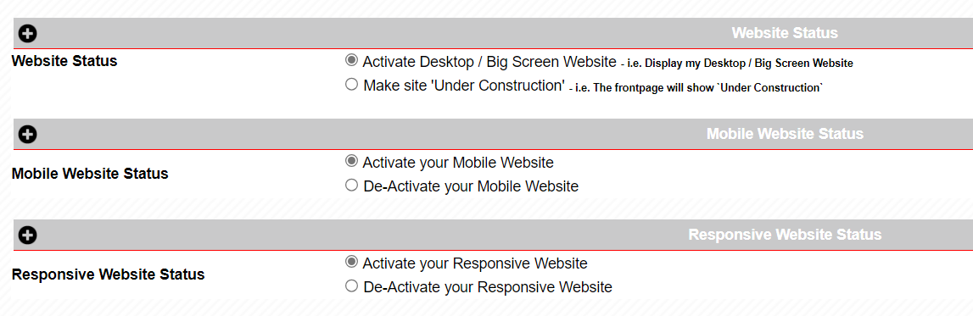

Scroll down to bottom of the page and click on update.

After choosing your template, you now need to add your own content to the website. When logging in the following will be displayed. After website is activated this will disappear.

Click on any space next, above, or below to above notification picture. This notification will disappear when you activate your website.

Switch Drag Drop editor to Standard editor.



To edit Home Page, click on Home Page.

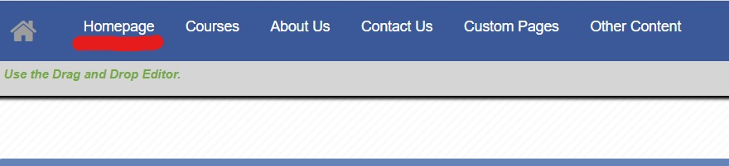

The following will show.



Below above picture is the content area to add and edit content and pictures.

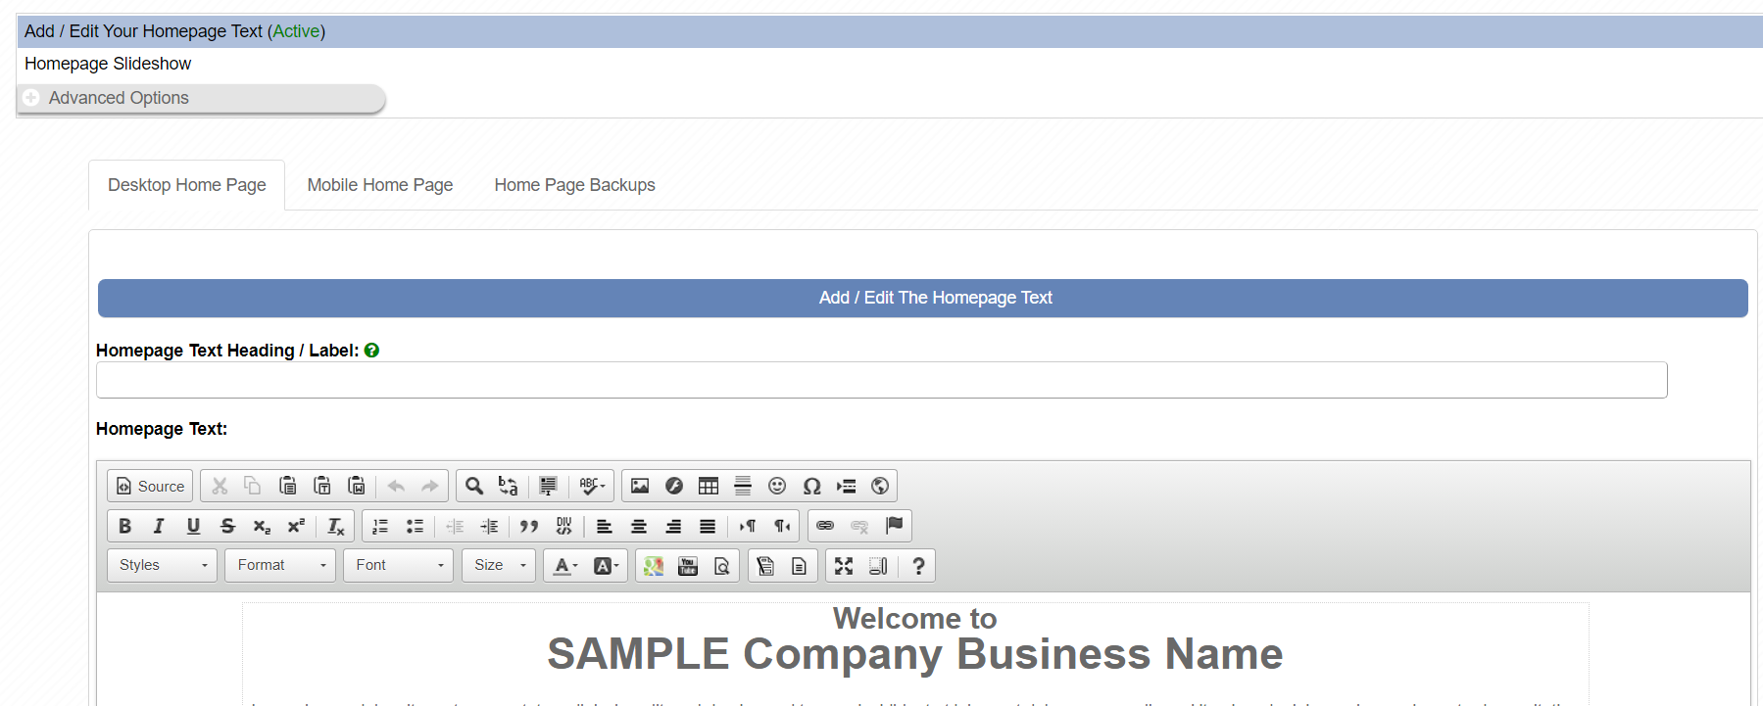

Below is your Editor to edit content.

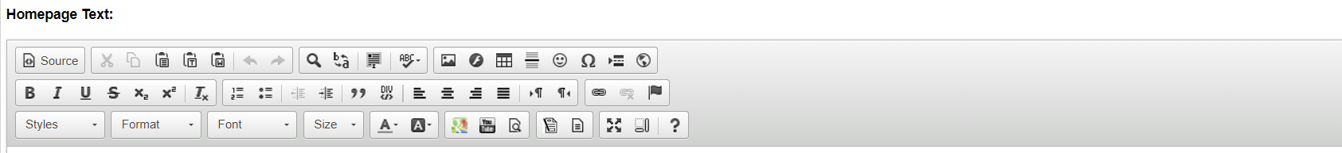

We recommend using Mozilla Browser. Click View website.

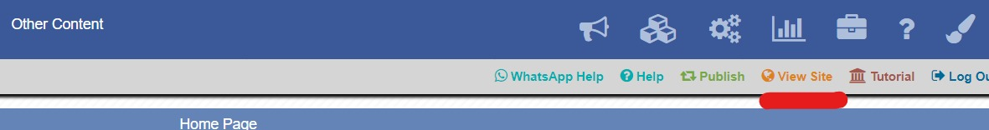

A new tab will open to display your website this is how your website will look live.

**3. Editor**

[**https://clientzone.kwikwap.com/login.php**](https://clientzone.kwikwap.com/login.php)

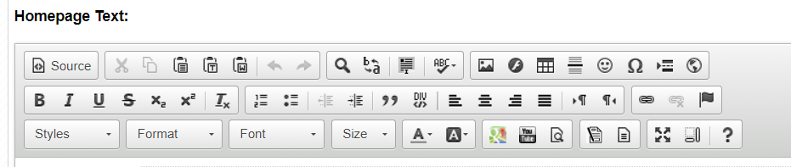

Source:

This shows your page source code. If you not familiar keep this as default and do not edit this.



Copy and paste. Use this option to paste from outside sources such as Word and more. Make sure you do not copy content from other websites as this will affect your SEO (Search engine optimisation).

Search, replace, select all and spell checker.

Insert Image, Flash, Table, Horizontal line, Smiley, Unusual character, page break and I frame.

Image: Insert or replace existing images, always shrink your images to help website load quicker.

Optimizing your images before uploading them to your website improves your website speed. Yet many beginners have slow websites simply because they upload unoptimized images.

1. Resize – paint or online app <https://tinypng.com/>
2. Compress – <https://tinypng.com/> or other.

<https://tools.pingdom.com/> For site speedtest.

<https://www.youtube.com/watch?v=DHtLC2SDIFM&t=2s> Video.

Flash. Not recommended

Table: Always type text inside a table.

Insert horizontal line.

Insert Smiley.

Insert Special characters.

Insert page break.

I frame. I Frame link Facebook page to your website.

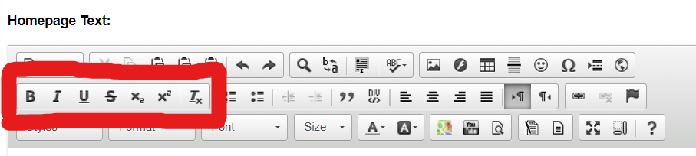

B: **Bold Text**

I: *Italic:* ***Italic Bold***

U: Underline text.

~~S~~: ~~Strikethrouh text.~~

X2: Text123abc.

X2: Text123abc.

*Tx*: Remove format.

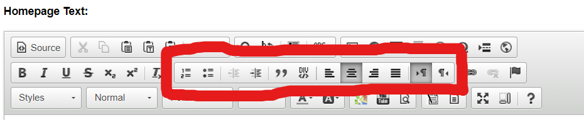

1. Number Text.
2. Number Text.

* Bullet Text.

Decrease Indent.

Increase Indent.

“Block Quote”

Create Div container:

Align left.

Centre.

Align right.

Text direction left to right.

Text direction right to left.

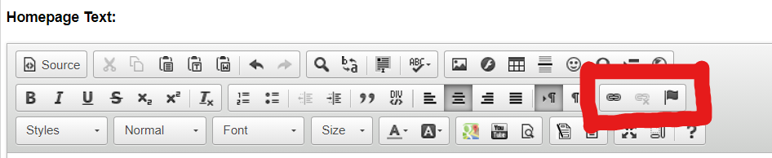

Insert hyperlink.

Unlink.

Anchor.

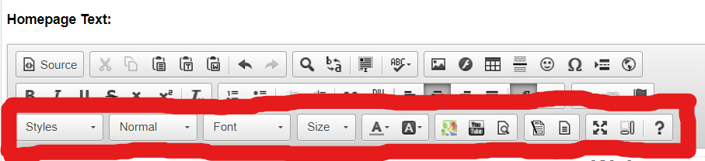

Styles: Scale In, Inline Styles, KwikTrakInBottom.

Normal:

* Heading1: Only 1 heading per page is recommended.
* Heading2,3,4,5,6: No limit per page.

Font: Choose your preferred font.

Font Size: We recommend 18 – 20 for normal text. Makes website easier to read.

Text colour only.

Text Background colour.

Insert your google map address.

Insert YouTube video your page.

Preview your page.

Insert contact Form.

Insert preset table templates.

Maximize page.

Show content in blocks.

About the editor.

4. Products, Services and SEO

<https://clientzone.kwikwap.com/login.php>

The most important part for your Online Store.

Add a new Product / Service

Product / Service Name: The name of the product / service.

Long Description: Describe your product / service in detail. The Description should be comprehensive (200 + words), and the keyword density should be between 2% and 4%.

Upload product photo. Follow guidelines insert picture in Home page description. Resize, compress save and upload.

Add product price. The price your product sells for.

Assign a group should your product belong to a group. E.g. Kitchen Appliances is the group. The group is created under Advanced options – Manage your Products / Service Groups. Products E.g. Toaster is then paired with Group Kitchen Appliances.

Click on Update product to add your product.

Right top click on publish-to-publish website to the web.

ADD Product:

Add product name.



Long Description

In Long description select Table

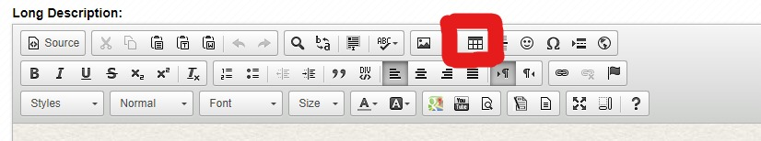

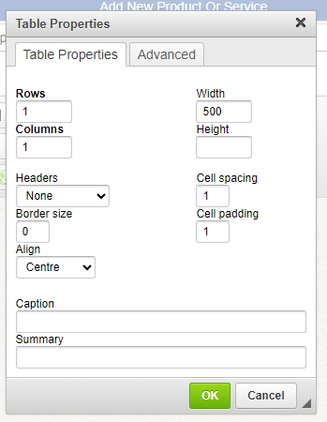

Click OK and add text inside Table.

Insert picture an resize picture to fit inside width of the table.

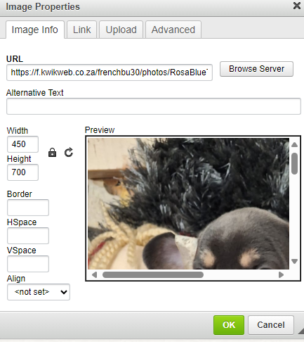

Click ok.

Add photo.

Assign to Group



Update / Delete an existing Product: Update or delete your product here. Also check your SEO here.

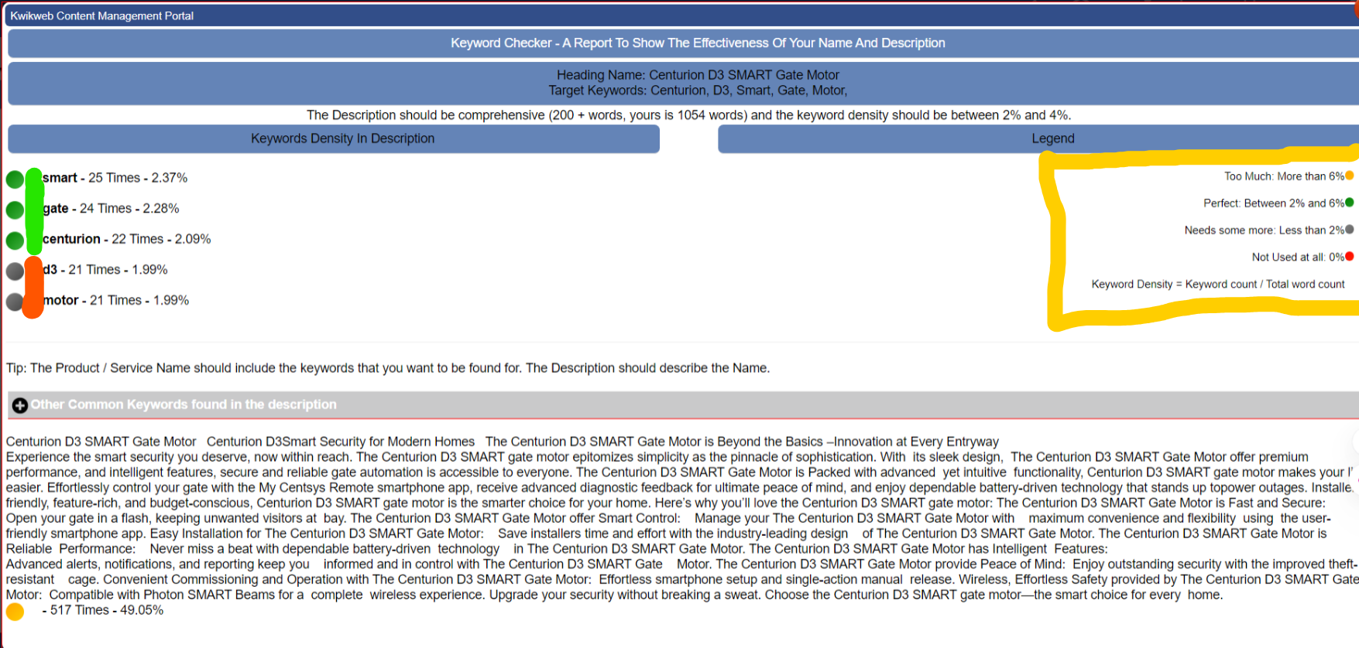

In above example Smart, Gate and Centurion has the correct percentage amount in the word number content.

D3 and motor needs attention and need to be added more in the content.

Right in yellow Legend to abide to.

Manage WhatsApp number: Add your WhatsApp to your website.

5. Template Image replacement:

Important you need to know image format, image size and image name.

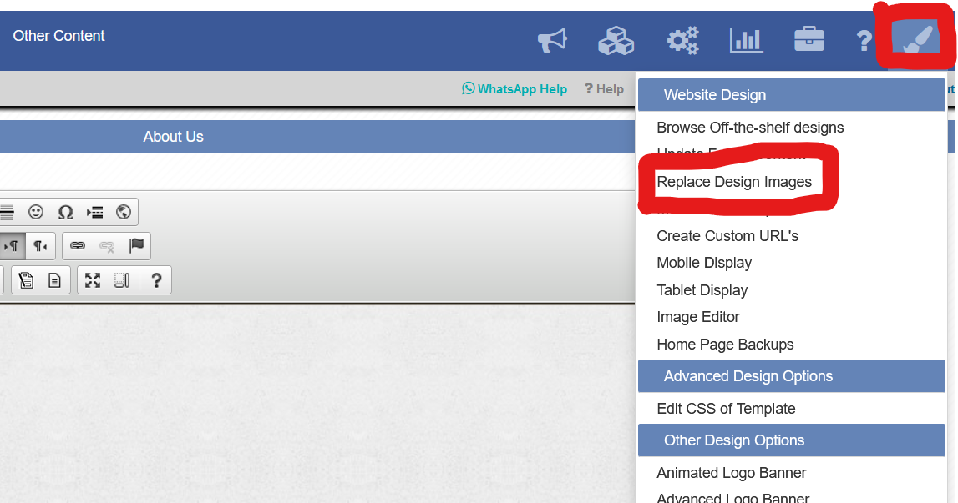

All template images will be displayed here.

Yellow - Download image. Always first download default image to keep for size and format reference.

Green – Upload your new image. This image should be the same size same name and same format in red above menun.png.

Blue – View your image.

Red – Name and format of template image, this must be the same in your new image to be uploaded.

For editing images Paint in windows will work or purchase an image editor like PhotoScape.

Use Mozilla browser this will assist with image information. Click view site your site will then open. In the site tab click CTRL and i. The following will open.

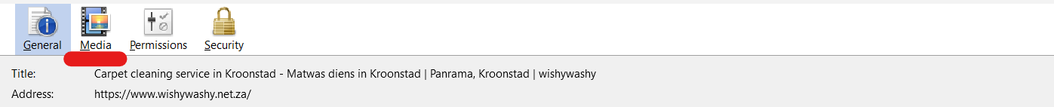

Select Media.

Red – Media all images on website page.

Yellow - Selected image.

Blue – Image name and format.

Green – Image Size.

After you edited your image upload the image on your portal. Please clean History and cookies on your browser. If not done old cookies will still be displayed and not your edited content.

**Also remember to always update and publish your edited content.!!!!!!!!!!**

**6. ADDING YOUR I-FRAME**

[**https://youtu.be/SkJ7PKs8PBQ**](https://youtu.be/SkJ7PKs8PBQ)

[**https://youtu.be/2QWQ1_BdHuA**](https://youtu.be/2QWQ1_BdHuA)

[**https://clientzone.kwikwap.com/login.php**](https://clientzone.kwikwap.com/login.php)

To integrate Facebook and maps to your website:

Facebook:

Log in to your Facebook page account. Retrieve your page address on top at the address bar.

Goto <https://developers.facebook.com/docs/plugins/page-plugin/>

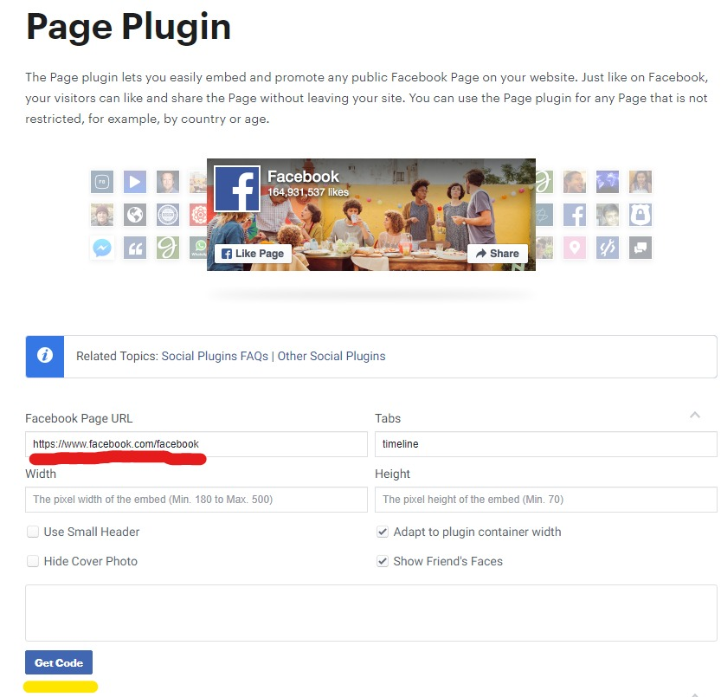

RED: Paste your Facebook Page URL

Yellow: Click on Get Code

Insert your address in Facebook address URL and hit the enter button.

Click on Get Code.

Click on I-Frame and copy the code from where https:// starts till the end. Leave out the content before this.

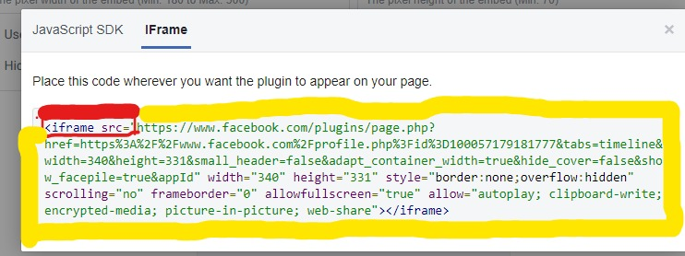

Red: Do not copy this. <iframe src=" including the”

Yellow: Need to be copied. Copy the rest starting with https:// till the end.

Login to your Kwikwap portal and insert your I-Frame in your editor.

I-Frame Maps

You need to add your business to google my business. Once done go to <https://maps.google.co.za> and find your business.

Red, find your business by typing your address or business name in the Maps search area.

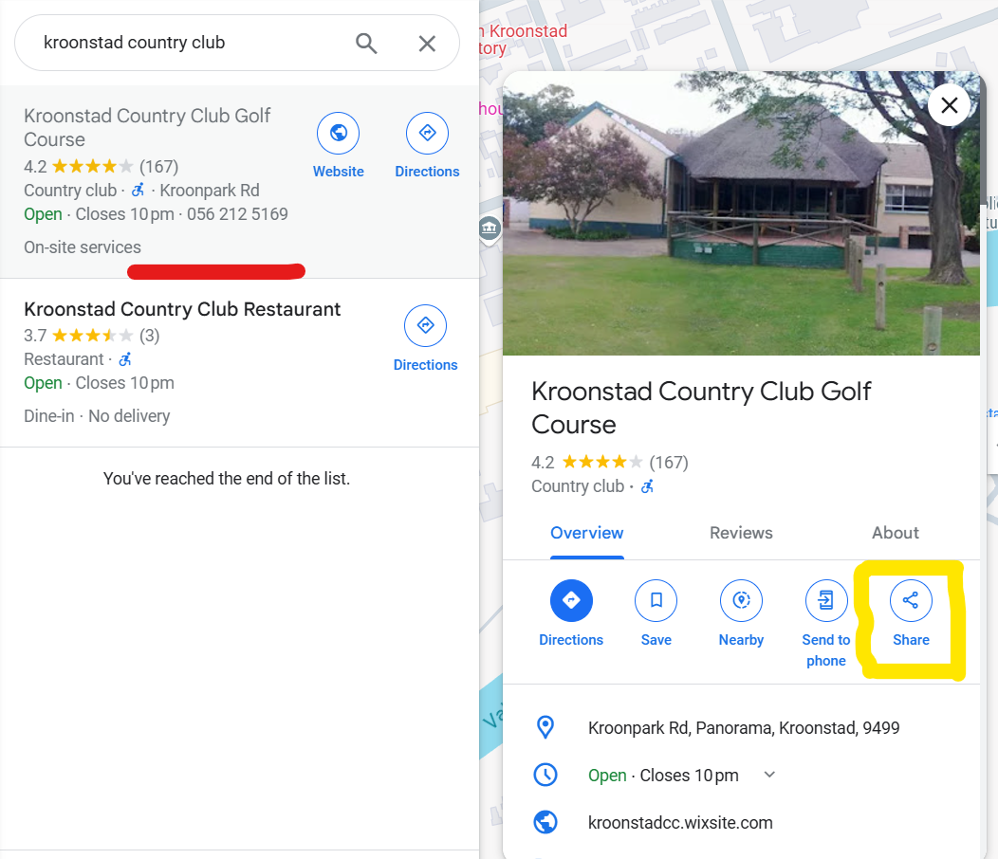

Red, click on your business name.

Yellow, Click on share.

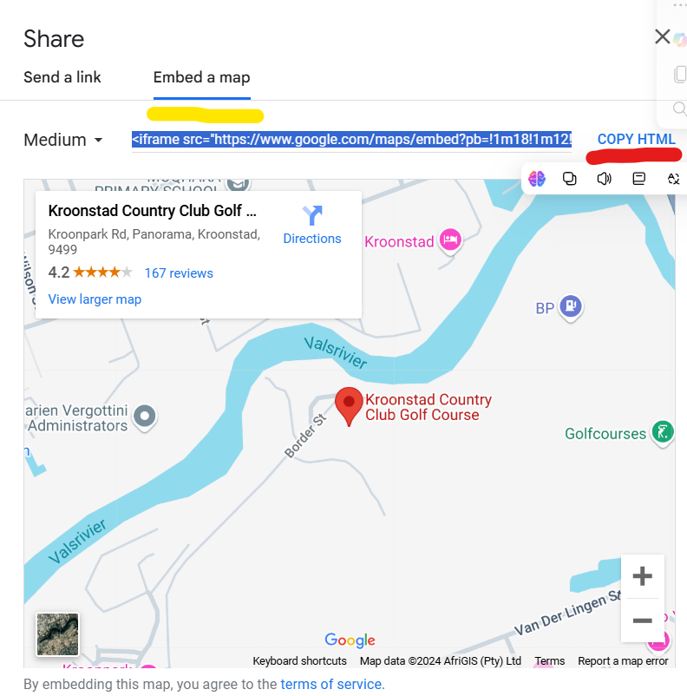

Yellow, click on embed a map.

Red, click on Copy HTML and paste the copied HTML in Word or Notepad

<iframe src="https://www.google.com/maps/embed?pb=!1m18!1m12!1m3!1d3533.691719123601!2d27.242527775485033!3d-27.665008125056247!2m3!1f0!2f0!3f0!3m2!1i1024!2i768!4f13.1!3m3!1m2!1s0x1e93e0a04a56c7af%3A0x826f36e6099a6af2!2sKroonstad%20Country%20Club%20Golf%20Course!5e0!3m2!1sen!2sza!4v1733388192776!5m2!1sen!2sza" width="600" height="450" style="border:0;" allowfullscreen="" loading="lazy" referrerpolicy="no-referrer-when-downgrade"></iframe>

In above example in your HTML do not copy red , copy only green starting with https:// and ending with ZA or your country name.

Go to your Kwikwap editor, find a space where you want your map to show click there and click on I-Frame in the editor.

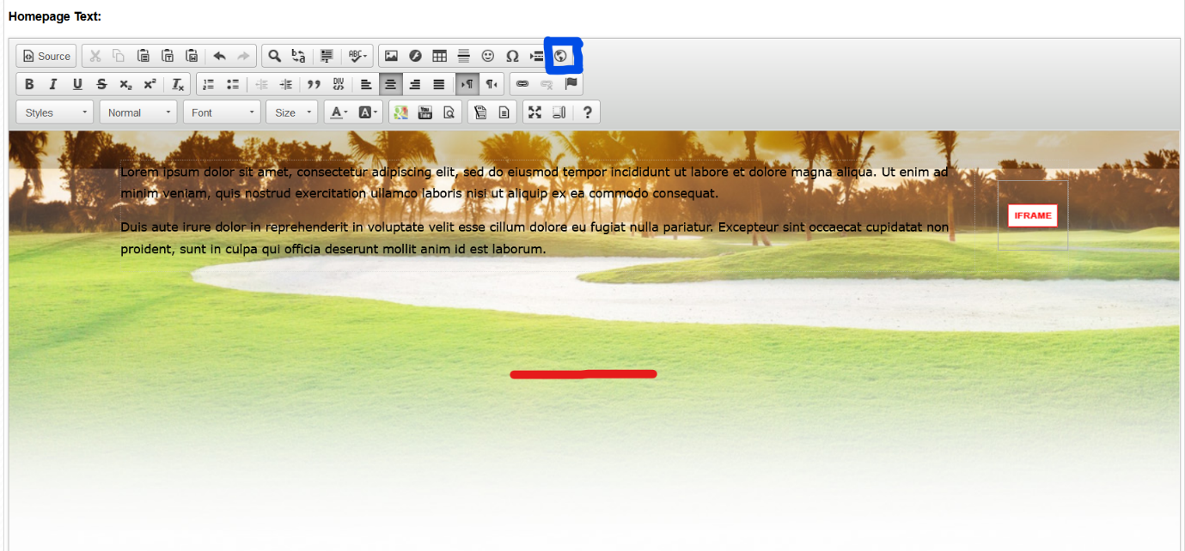

Blue, I-Frame icon.

Red, Place I want to add I-frame.

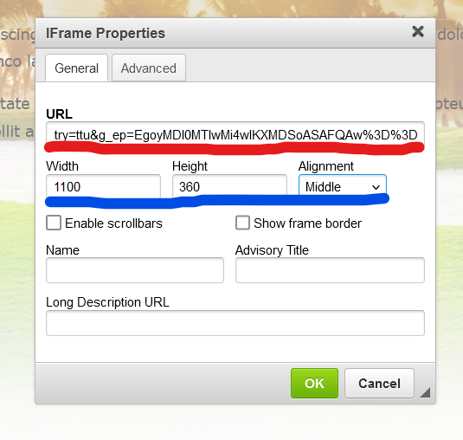

Red, paste your google map URL.

Blue, Set your preferred size and placement.

Click OK.

Click Update.

Click Publish.